Set PATH to JDK on Windows 8

After downloaded and install JDK 8 on Windows 8, now open a Command Prompt window to run java or javac...!!!

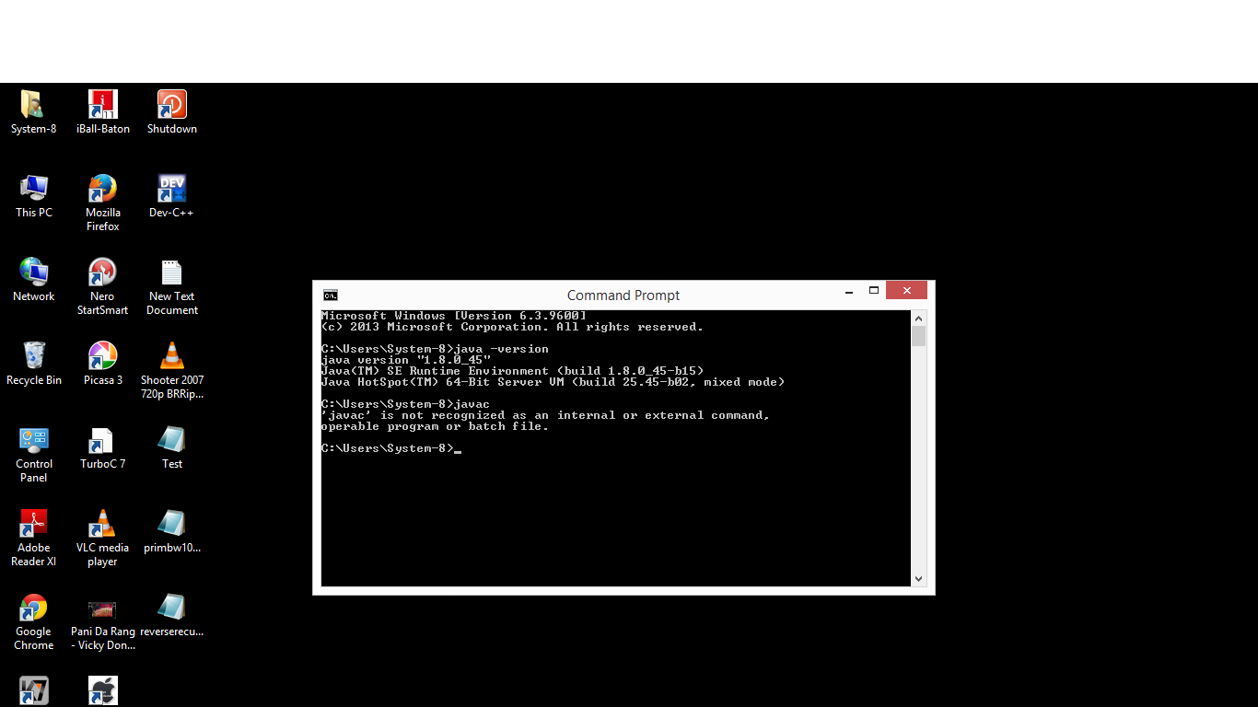

You can optionally set PATH environment variable to JDK so that you can conveniently run the JDK executable files (javac.exe, java.exe, javadoc.exe, and so forth) from any directory without having to type the full path of the command.  
  
To set path, search "Environment Variables" in "Settings", click "Edit the system environment variables".

[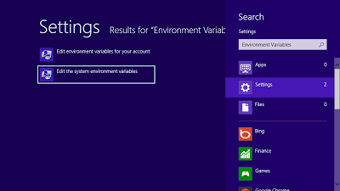](http://2.bp.blogspot.com/-kOPn5XnQITM/UPbfk69AwxI/AAAAAAAABLA/Bsaz5BFld1Y/s1600/setpath_02.png)

Or

Right click on This PC (or My Computer) and choose properties which display “System” window.



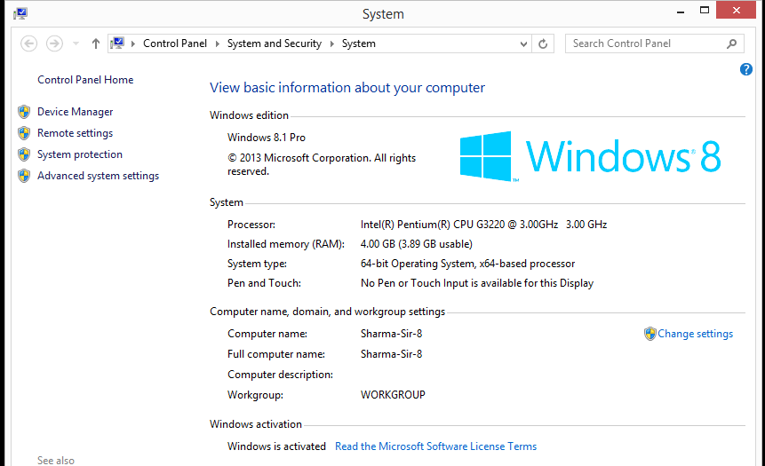

Click “Advanced System Settings” from System window.

Click "Environment Variables".

[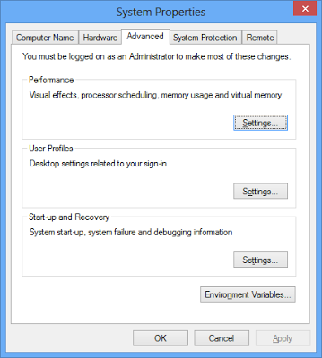](http://1.bp.blogspot.com/-1mNz0N0scsE/UPbfk-S7UBI/AAAAAAAABK4/GKcP41Ew6tk/s1600/setpath_03.png)

Select System variables of Path, and click Edit...

[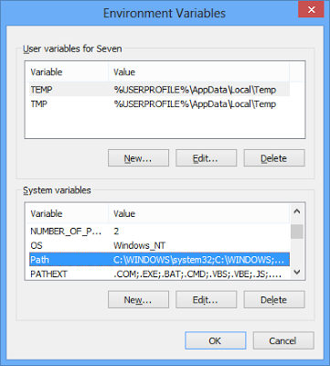](http://2.bp.blogspot.com/-KL3cPYU2YV8/UPbflnG3PrI/AAAAAAAABLE/_uuB8nX9_X4/s1600/setpath_04.png)

Add the location of the bin folder of the JDK installation at the end of variable value, in my case it is "C:\Program Files\Java\jdk1.8.0_45\bin". Don’t forget to put semicolon before the above path as given in the following picture.

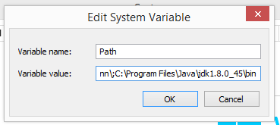

Now, you can close and re-open Command Prompt window, type java and javac to varify your setting.

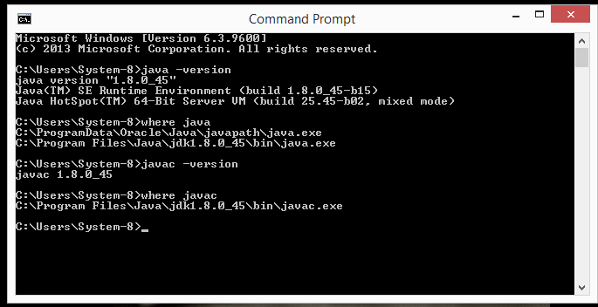

Note : If oracle is also installed in the system, then it is always better to paste the path "C:\Program Files\Java\jdk1.8.0_45\bin" at the beginning of variable value followed by a semi-colon(;), otherwise it will sometime provide unexpected result.